

**UNIVERSITY OF NAIROBI**

**COLLEGE OF BIOLOGICAL AND PHYSICAL SCIENCES**

**SCHOOL OF COMPUTING & INFORMATICS**

**UpMeet**

Meeting venue Reservation System

**By**

**Biwot Denis Kipkoech**

**P15/1731/2017**

**Supervisor**

**Selina Atwani Ochukut**

A project report submitted in partial fulfilment of the requirement for the award of

Diploma in Computer Science of the University of Nairobi.

July 2020

## UNDERTAKING

I declare that the work presented in this project titled “*UpMeet*”, submitted to the College of Physical and Biological sciences, School of Computing & Informatics, University of Nairobi is my original work and has to the best of my knowledge, not been submitted to any other institution of higher learning.

**Student:** Biwot Denis Kipkoech **Reg. No**: P15/1731/2017

**Signature**………………………………… **Date**: ……………………………

This project has been submitted as a partial fulfilment of requirements for the Bachelor of Science in Computer Science of the University of Nairobi with my approval as the University Supervisor.

**Supervisor**: Selina Atwani Ochukut

**Signature**: ………………………………… **Date**: …………………………….

## DEDICATION

I dedicate this project to my family for their unwavering support and love. They provided the necessary support required to progress through the ranks. Special thanks to my mother for always being present and volunteering to be a beta tester for the application. Special thanks to my sister for being the ever-available support.

## ACKNOWLEDGEMENT

I owe my sincere gratitude to my project supervisor, Selina Atwani Ochukut for helping me through the process where she could, vividly pointing out the mishaps in my system, pointing out my mistakes, giving advice and her effort in trying to make me a better system developer in the real world.

I also express my deepest gratitude to my fellow classmate David Suge for continuous support, ideas and advice.

I thank God for giving me strength and good health to the completion of this project.

## ABSTRACT

A drastic change in viable business models has given rise to a number of office-less jobs and companies. Most of these are startups with a few employees and freelancers while others are full scale companies with hundreds of employees (Like GitHub). These companies do not need to have physical offices as its employees work remotely.

It seems plausible to completely do away with physical brick-and-mortar offices however, a few cases like team-building, meetings with high profile clients, meetings with investors and annual catchups still require physical venues for face-to-face conversations.

UpMeet provides such companies or people (freelancers) a way of **acquiring office space for the period they require (as short as a day)** without having to pay a full month’s rent. It eliminates the hassle of time-consuming research on the internet in search of suitable venues and the gruesome negotiations.

The system provides vacancy status, venue details (including price and pictures), reservation and search based on location or proximity. Venues are populated on a map and can be easily accessed by seekers. Seekers are navigated to the venues via an integration with google maps and can pay via mobile money.

The system is mobile based to utilize the use of mobile specific features like GPS, STK, availability and push notifications.

Owners of the venues sign up, add their venues for cataloging and update appropriately. Seekers search for, **reserve and pay for venues**.

The system has a **built in AI assistant** called Ana. Ana is a limited memory-type artificial intelligence. She is a chat-bot that can process natural language and make out user intents. This way she can communicate with application users, guide them and provide them the information they are looking for.

The system will appeal to venue owners as it provides them exposure, indirect advertisement and a wider reach of customers. Missing out on the system would mean missing out on a portion of customers hence losing out to competition – Similar to bus providers and their allegiance to *Buupass*.

This paper takes you through in detail the process of developing the system, the outcomes, precedence, liabilities, and recommendations.

## TABLE OF CONTENTS

UNDERTAKING 2

DEDICATION 3

ACKNOWLEDGEMENT 4

ABSTRACT 5

TABLE OF CONTENTS 6

CHAPTER1: INTRODUCTION 8

**1.1: Background** 8

**1.2: Problem statement** 9

**1.3: Goals and objectives** 9

**1.4: System development objectives** 9

**1.5: Project justification** 10

CHAPTER 2: LITERATURE REVIEW 11

**2.1: Overview** 11

**2.2: Similar systems** 12

CHAPTER 3: SYSTEM ANALYSIS AND DESIGN 14

**3.1: System analysis** 14

**3.2 System design** 24

CHAPTER 4: SYSTEM IMPLEMENTATION 31

**4.1: Resources** 31

**4.2: Constraints** 31

**4.3: System testing** 31

**4.4: Unit testing** 31

CHAPTER 5: CONCLUSION AND RECOMMENDATION 36

**5.1: Achievements of the system** 36

**5.3: Challenges and limitations** 36

**5.4: Further improvements** 37

**5.5: Conclusion** 37

**5.6: Appendix** 38

**LIST OF FIGURES**

*Figure 1*: The waterfall development methodology

*Figure 2*: UpMeet Use case

*Figure 3*: UpMeet Context Diagram

*Figure 4*: UpMeet Level 0 DFD

*Figure 5*: Conceptual model representation of UpMeet

*Figure 6*: Venue Seeker Flow Chart

*Figure 7*: Venue Owner flowchart

*Figure 8*: UpMeet Database Structure. Firebase (Real-time)

*Figure 9*: Welcome page with the app’s icon

*Figure 10*: Add Venue Activity where the owner adds his/her venue.

*Figure 12*: (Profile) Inform user when field is not entered correctly.

*Figure 13*: (Sign In) Prompt user when wrong password is entered.

*Figure 14*: Code in main activity (Navigation Activity) that requests user for location permission

*Figure 15*: Code in Facility Details activity that retrieves facility data from firebase.

**LIST OF TABLES**

*Table 1*: Matrix representation of venue reservation

*Table 2*: UpMeet test cases

*Table 3*: Project Schedule

## CHAPTER1: INTRODUCTION

### **1.1: Background**

When anyone thinks of a workplace or company, they imagine commuting employees, management and a physical building.

Change is inevitable and the future of workplaces is no exception. Working remotely is a trend that is quickly picking up fueled by the constant improvement of network coverage, internet speeds and introduction of apt collaboration tools. It is believed commuting to work every day will turn to a thing of the past in a not so distant future. Employees could work from home and be summoned only when required physically.

The global COVID-19 pandemic has disrupted most workplaces and the workings of the office will certainly never be the same. Companies have been forced to adapt against their normal business models to employees working from home and this will no doubt speed up the transition.

#### **The rise of office-less companies**

"Talent is evenly distributed but opportunity is often not," says Cate Huston. "Working this way means you can access that talent and also give opportunity." "I'm office-free. We all just love the freedom and we travel to meet each other so we enjoy those adventures as well." She was interviewed by BBC Radio’s Felicity Hannah, (Hannah, F, 2019).

She leads the developer experience team for Automattic, a large multi-national company where every single one of the 930 staff work remotely. The business has no fixed office presence at all.

More than half of current jobs are information-based and do not rely on an employee’s presence to run. This implies that the switch to remote work is possible now more than ever. Implementing it will plausibly be seamless for most employees and companies.

Faster internet connections, messaging and video apps, and the rise of collaborative and monitoring software are allowing some firms to do away with their offices entirely.

Instead, they hire staff from multiple locations and ask them to work from home or from shared working spaces near where they live

#### **Making offices optional**

The bottom line is that a virtual company can be just as viable, professional, and successful as a traditional on-site company, and even more so (Jessica S, n.d). Some critical functions of physical offices cannot however be overlooked. The transition to completely office-less workplaces will have to accommodate for the periodic need for a physical place to meet acquiring a place only when you really need it.

### **1.2: Problem statement**

Change in business models mean office spaces and facilities are not as crucial as they were before. A means for facility lease for a shorter period is required to ensure reduction of overhead costs on employees, freelancers and companies.

### **1.3: Goals and objectives**

The main goal of this undertaking is to allow for reservation and payment of cataloged meeting and office facilities for a period shorter than a month by developing an application that:

* Enables venue owners to add their venues and corresponding facilities
* Enable facility seekers to find appropriate venues based on prices and appearance and location.
* Allow owners to add their venue locations and populate on the map using Google Places API
* Acquires seekers location and displays venues closest to him/her
* Enable seekers to reserve space and
* Integrates with Daraja M-pesa for easy mobile payment
* Provide the user with support navigating the application

#### **1.3.1: Research objectives**

* Research on major challenges facing startups and freelancers
* Research on average prices of office space in Nairobi
* Research on similar existing systems

#### **1.3.2: Research topics**

* Applications of mobile in the office – To understand how this proposed application will fit into the market
* Daily workings of the office – To acquire insight on facilities and their usage
* The current state and future of the office and its equipment. – To adapt and ensure the system is appropriate.

### **1.4: System development objectives**

* **Gathering requirements** - Through research and interviewing relevant parties
* **Design** - Develop the layout of the app and how the users will interact with it.
* **Testing** - Testing all the features of UpMeet to make sure they function properly and have no bugs. Sample users will be sent an APK for testing.
* **Deployment** - The app will be packaged an APK interested parties can use. It will in later stages be uploaded to google play store.
* **Maintenance** - The app will undergo updates, which will include: - adding features, performance enhancements.

### **1.5: Project justification**

When in Nairobi one can see many office buildings with TO-LET signs on them – this shows the availability of offices and meeting facilities. The changing needs for these facilities show that there is certainly a need for a means of reserving a venue only when needed. This would help decrease overhead costs for freelancers, startups and office-less companies. Furthermore, unoccupied venues would generate revenue – a win-win for both parties.

## CHAPTER 2: LITERATURE REVIEW

### **2.1: Overview**

#### **2.1.1: The future of offices and the impact of COVID-19**

Experts believe the future of offices is no offices at all (Kaya I, 2019). Employees won’t have to go to work every day as it is in the current workplace setup. Employees could be anywhere in the world but still fulfil their stipulated obligations.

Furthermore according to (Kaya I, 2019), with a distributed workforce, much of the overhead expenses like office space, cleaners, supplies and more are virtually eliminated. Add to that, employees won't have to deal with dry cleaning expenses for daily business attire and will no longer have to deal with the high cost of commuting.

According to Charles Russels Speechlys LLP- a law firm headquartered in London (Khan U, 2020) with offices in the UK, the current pandemic is giving businesses an opportunity to assess the viability of remote working against their business models. Some will inevitably conclude that they simply do not need the amount of office space which they have needed up until now. These businesses may, for example, ask some staff to work remotely on a permanent basis or may even adopt a model where staff rotate the days on which they are physically present in the office, potentially cutting the amount of space required by half or more.

The COVID-19 pandemic is highly likely to speed up the switch away from physical offices. Companies on re-opening will have to think about decongesting their workplaces to comply with government guidelines. Bold companies that could survive the migration could even take a leap of faith and do away with the conventional brick-and-mortar offices. They could have their workforce work remotely and reserve physical venues only when necessary – Something UpMeet will be able to carter for.

#### **2.1.2: Why mobile?**

A recent study (Ofcom, 2018) showed that the average adult in the UK spends an average of 2 hours 28 minutes on their mobile devices. Mobile devices have become a must-have. They are now an integral part of our lives and everyone – young or old possess one and whenever we want something the first place we go to look is on our mobile devices. According to (Google Fundamentals of digital marketing, 2020), when designing a system it is best to go where the people are – in this case it is on the mobile devices.

To add on to the already piled list of reasons, mobile devices provide extra features that can be utilized to improve usability and user experience. These include; GPS to find user location and navigation, cameras to take photos on the go and mobile payments using STK.

### **2.2: Similar systems**

#### **2.2.1: Picktime**

Picktime is a free online room booking software with which you can book a meeting room from any part of the world with just an internet connected device. You can schedule a meeting remotely from any place with an internet connection. Its key features include:

* It is free to use
* Has reminders
* Has 24 hours’ support

###### Cons

* Only web based meaning nothing is available offline
* It is only virtual

#### **2.2.2: Skedda**

Skedda is a venue advertisement platform where Venues pay to get featured. Venues are provided with schedules to organize their events and are connected with paying customers. The system is entirely web based and has features such as room management and calendar syncing. Using and navigating the system gives the user a premium feel as the design is smooth and fast. All this comes at a hefty price though. Skedda system also supports users logging in with existing accounts such as Microsoft or Google accounts. The advantages Skedda poses include;

* It is not limited to a particular venue like offices or hotels.
* Premium feel
* Flexibility and diversity of functionalities

###### Cons

* Very expensive
* Nothing happens offline

#### **2.2.3 Planning Pod**

Planning pod is a venue management software that aims at ensuring smooth running venue activities. The system provides tools to aid venue staff at carrying out their task. It helps manage bookings with a dedicated drag-and-drop, color-coded bookings calendar. The system syncs with e-calendars therefore organizing schedules and notifying staff of conflicting bookings. Furthermore, it temporarily reserves dates and spaces for prospects and notify of time conflict alerts so spaces are never double-booked. The main advantage of Planning Pod is how it smoothens venue activities

###### Cons

* Focuses a lot on venue owners neglecting seekers in the process
* It comes with a heavy price tag
* Has been criticized for being complex and difficult to navigate
* Nothing happens offline.

## CHAPTER 3: SYSTEM ANALYSIS AND DESIGN

### **3.1: System analysis**

#### **3.1.1: Introduction**

System analysis refers to the process of examining the proposed system to understand its constraints, procedures and functions. It therefore involves gathering information on how the proposed system can be built to suit user needs and still perform effectively all the requirements required of it.

I needed to understand the process of what the new system will do and how it will work

The analysis phase of system development produced a high level description of the system

The activities I carried out during this phase include;

* Gathering information
* Defining system requirements
* Prioritize requirements
* Generating and evaluating alternatives
* Reviewing

#### **3.1.2: Feasibility study**

Analysis to measure the ability and likelihood to successfully complete a project including all relevant factors accounting for factors that affect it such as economic, technological, legal and scheduling factors.

I used feasibility studies to determine potential positive and negative outcomes of the project before investing a considerable amount of time and money into it. Instead of diving into the project and hoping for the best, the feasibility study acts as a precursor to investigate the possible negative and positive outcomes of the project before investing too much time and money.

##### **Operational feasibility**

Operational feasibility refers to the measure of solving problems with the help of a new proposed system. It helps in taking advantage of the opportunities and fulfills the requirements as identified during the development of the project.

There is a market need for a platform to bring together public spaces for easy finding and comparison by the end users. Users won’t have to go web crawling seeking for and comparing public spaces. Users would be aware of vacancies and book spaces from the comfort of their mobile phone. The project has a target problem faced by the public and will therefore find its place in the market.

##### **Technical feasibility**

Technical feasibility refers to the realistic nature of the system in regard to available technical resources and the know-how of the target group.

The system is android based and is hosted using Firebase. Development is done using Android studio both of which are free. Some prior knowledge (Android development using Java) is required for development but this only affects the developer.

The application runs on all android enabled devices. As of now, most people in the country’s population own and know how to use a mobile phone running android which makes the project technically maneuverable.

##### **Schedule feasibility**

Refers to the practicality of the time within which the system is to be developed, all aspects integrated and deployed.

The time provided by the University (Two semesters), is sufficient for full development of the project from data gathering, analysis, design to implementation and testing

##### **Economic feasibility**

It is the analysis of a project's costs and revenues in an effort to determine whether or not it is logical and possible to complete. No support softwares will be bought during the development of the system. Most of the softwares used is provided for free to use including version control systems. However, time and the know-how of the programmer used to develop the system must be paid for (If the project goes to the real world). The system, if commercialized, could have other fees that I am yet to explore.

#### **3.1.3: Development methodology**

The model used in development of the system is the **Waterfall Model.**  An incremental approach was preferred over an iterative one, this means the system is developed with few subsystems. More functions are then gradually integrated to the system while functional and in use.

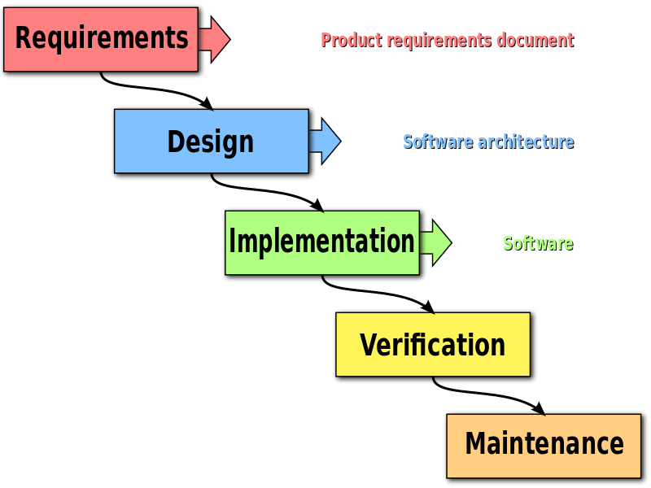

Figure 1: The waterfall development methodology

#### **3.1.4: Data gathering**

Data gathering involves using various techniques to collect needed re about a system to be developed. I gathered data from individuals or sources that are affected by the system, have interacted with similar systems before or contain information about the proposed system. The data collected is very important as it guides me (the programmer) on what is needed.

Methods that I used to gather information required to develop the android-based system are;

* Visiting the workplace
* Reviewing similar systems
* Visiting sites and carrying out research
* Interviews

##### **Visiting the workplace**

I visited the numerous offices to find out the daily workings of the office and get further insight

##### **Reviewing similar systems**

On noticing the gap, I researched to find out existing systems. These include Picktime and Skeeda both of which are excellent applications and web apps. Reviewing these similar existing systems gave me a deeper insight, helped me improve my system and highlighted features the other providers failed to notice. The existence of these systems also boosted my morale as it showed that this is a real existing problem worth looking at

##### **Visiting sites and carrying out research**

It is definitely the approach that was most used. A lot of information is found on the internet- the challenge lies in filtering out credible information from bogus. Most of the research carried out was over the internet including reviewing existing systems (To review the system I had to visit their sites over the internet).

#### **3.1.5: Data analysis**

Involves analyzing gathered data to acquire information required to develop the proposed system. It involves outlining functional and non-functional requirements the proposed system is meant to fulfil. Nonfunctional requirements (NFR) are requirements that specify criteria that can be used to judge the operation of a system, rather than specific behaviors whereas functional requirements define specific behavior or functions.

##### **Functional requirements**

Functional requirements are requirements that define specific behaviors of the system. They directly define how the system must function to fulfil its function and be considered complete.

Functional requirements of the system include;

* The system should allow for booking of venues
* The system should keep venue data cataloged and organized
* The system should ensure valid information is entered
* The system should return credible information (Integrity)
* The system should allow a user account be created
* The system should have safety measures including encrypted passwords
* The system should have a search feature based on location
* The system should show proximity to the venue.
* A user must be registered to book a space or register his/her venue

##### **Nonfunctional requirements**

Nonfunctional requirements (NFR) are requirements that specify criteria that can be used to judge the operation of a system, rather than specific behaviors

Nonfunctional requirements of the system include;

* The system should be reliable
* The UI must be simple and vivid
* The system must be lightweight
* The system should have fast responses
* The system should be easy to maintain

#### **3.1.6: Use case model**

Use case diagrams are usually referred to as behavior diagrams used to describe a set of actions (use cases) that some system or systems (subject) should or can perform in collaboration with one or more external users of the system (actors).

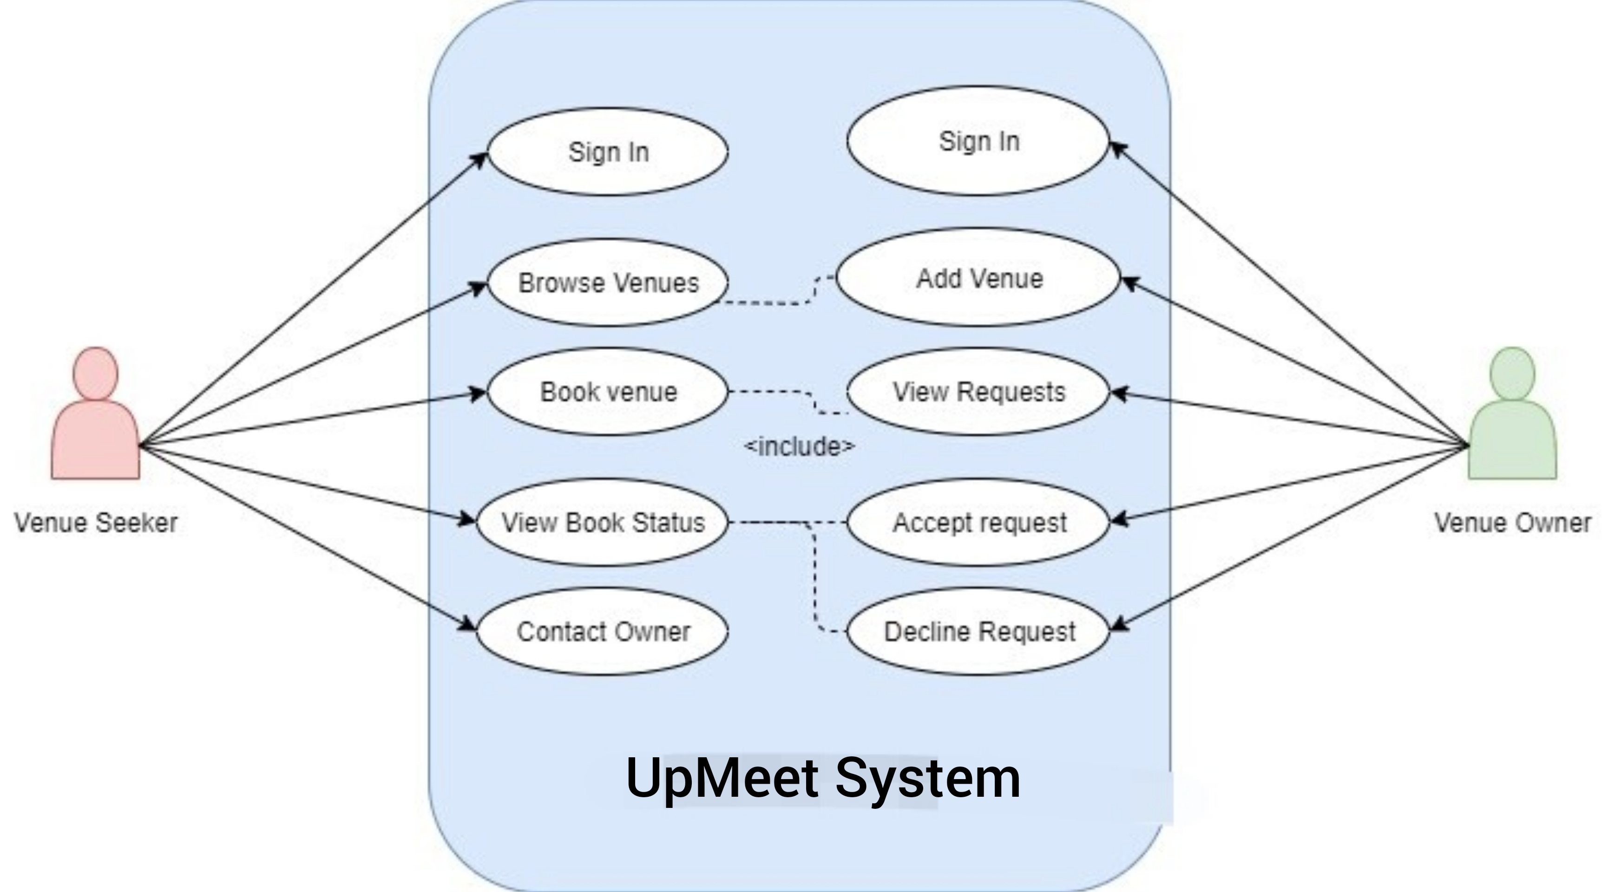

Figure 2: UpMeet Use case

##### **Actors**

The system has two main actors- both are users of the system;

* The venue owner
* The venue seeker

##### **Use Cases**

Use cases describe how the actors interact with the system. The use cases in this scenario describe the interactions of the venue seeker and venue owner and their interactions with the UpMeet system.

The seeker can;

* Sign up
* Sign in
* Reserve a venue (Even those without official websites or local business listings like Google My Business)
* Pay for a venue via mobile money
* View booking history
* Search for venues based on location
* View venues closest to him/her
* View photos and prices of venues and facilities (Aid in decision making)

The owner can;

* Sign up
* Sign in
* Add venue
* Add Facilities
* Show venue on the map
* View venue reservation requests
* Contact seekers
* Get notified of a new booking(Push notifications)

Table 1: Matrix representation of venue reservation

|  |  |
| --- | --- |
| **Matrix representation of Venue reservation application** | |
| **Name** | Venue reservation |
| **Brief description** | Enables the seeker to show reserve his/her place in the facility for a day |
| **Flow of Events** | The user seeks the venue he/she wishes to book. The user clicks and details of the venue appear (Varying for different venues). The user reserves and pays for the venue if a vacancy exists |
| **Special**  **Requirements** | The user should have all the details required for the venue application to go through |
| **Pre-Conditions** | The user must exist in the system |
| **Post-Conditions** | The system should view his/her applications |

#### **3.1.7: Data flow diagrams**

##### **Context diagram**

A context diagram is used to describe objects in the system and the various relationships between them. It is composed of classes, the various attributes and operations that can be performed on each class and their relationships.

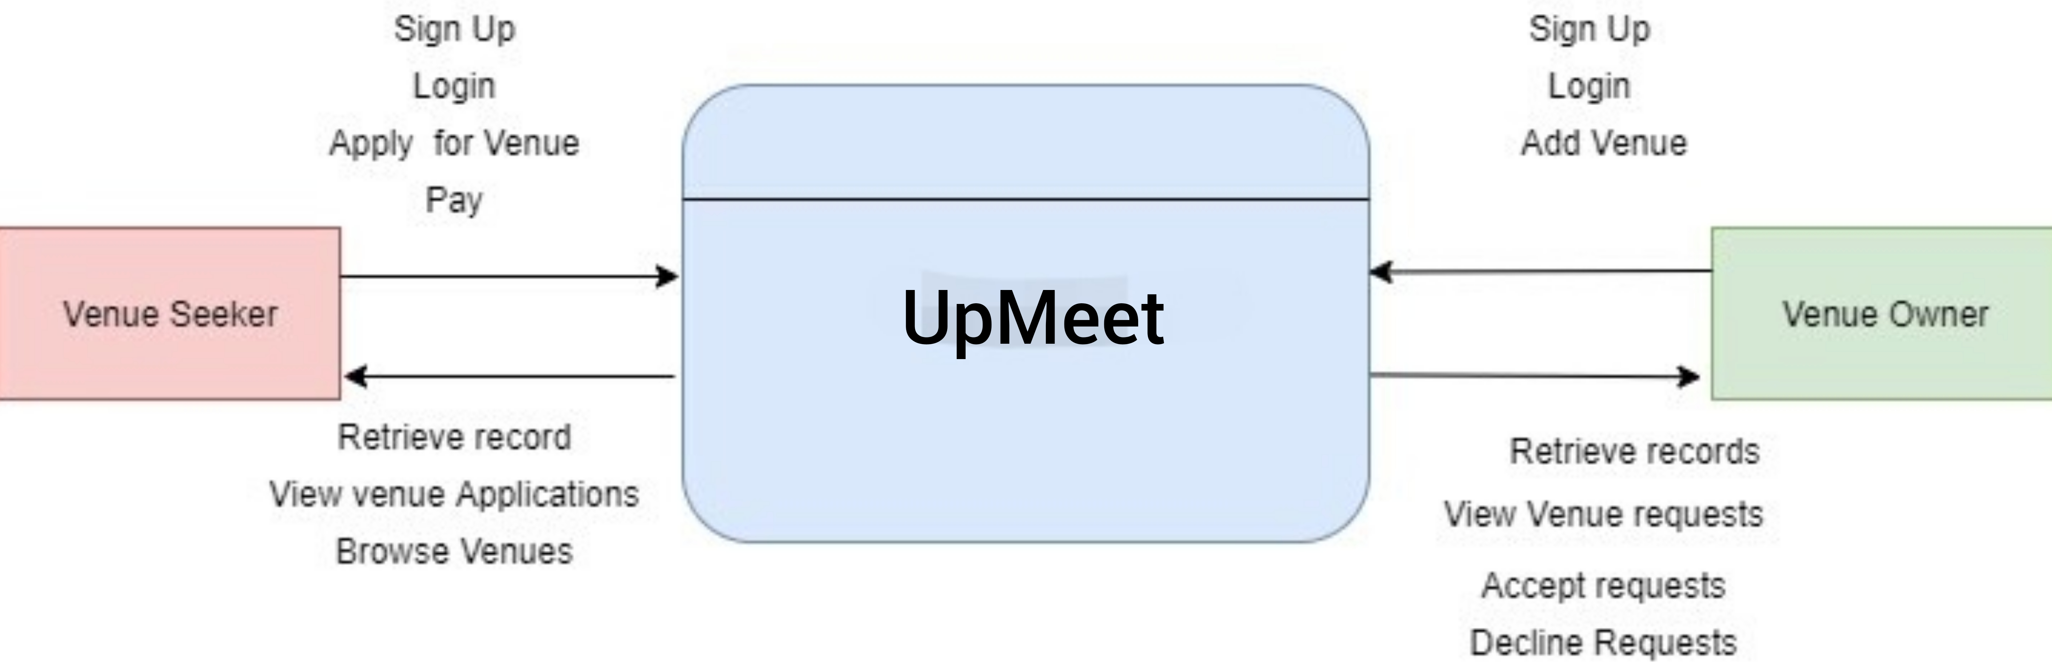

Figure 3: UpMeet Context Diagram

##### **Level 0 Data Flow Diagram**

This is a diagram that explains in depth how data flows in the Self-Help loan system between the users and the system.

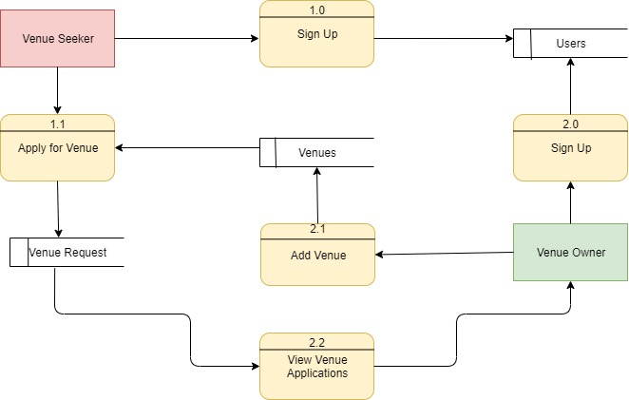

Figure 4: UpMeet Level 0 DFD

### **3.2 System design**

#### **3.2.1: Introduction**

Systems design is the process of defining elements of a system like modules, architecture, components and their interfaces and data for a system based on the specified requirements.

Designs for the proposed system are made following the results of requirement analysis. The system was designed in accordance to ensure all functionalities are included in the system.

#### **3.2.2: The conceptual model**

A conceptual model is a representation of a system that uses concepts and ideas to form said representation.

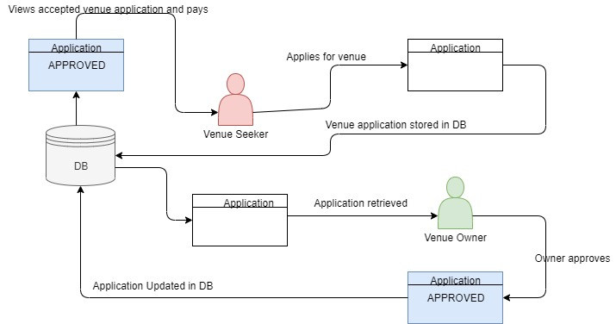

Figure 5: Conceptual model representation of UpMeet

#### **3.2.3: System flow charts**

##### **Venue seeker Flow chart**

Shows the process the venue seeker goes through when navigating and using the system.

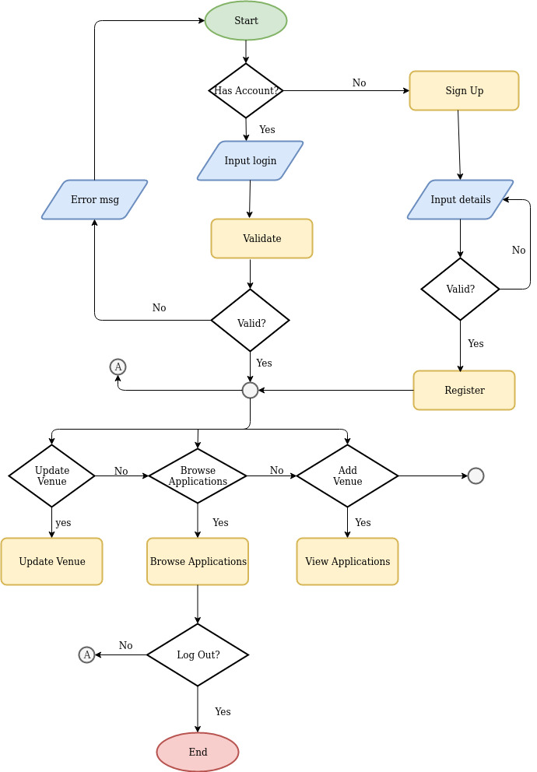

Figure 6: Venue Seeker Flow Chart

##### **Venue owner Flow chart**

Shows the process the Venue Owner goes through when navigating and using the system. 

Figure 7: Venue Owner flowchart

#### **3.2.4: Database Design**

The system uses a firebase real-time database. It is also a NoSQL database and stores data in storage in a structure similar to JSON’s.

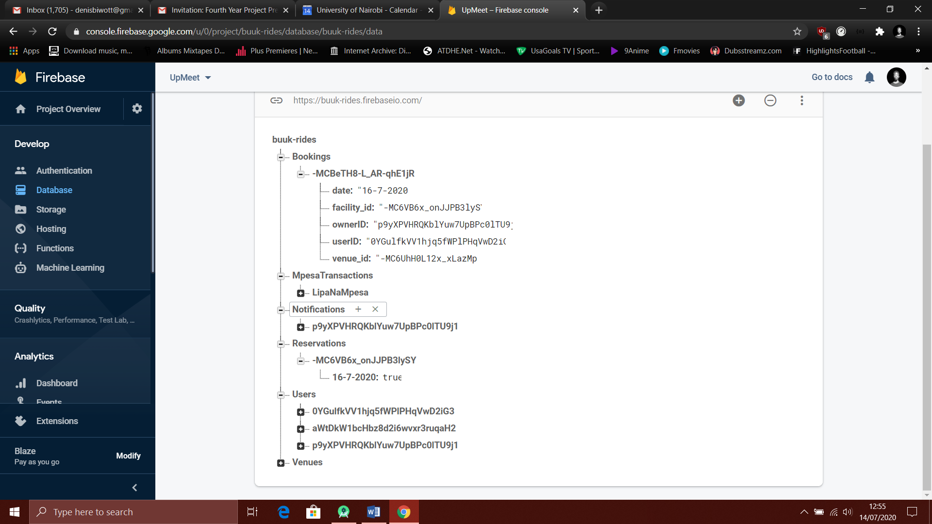

Figure 8:UpMeet Database Structure. Firebase(Real-time)

#### **3.2.5: UI Design (Sample screenshots)**

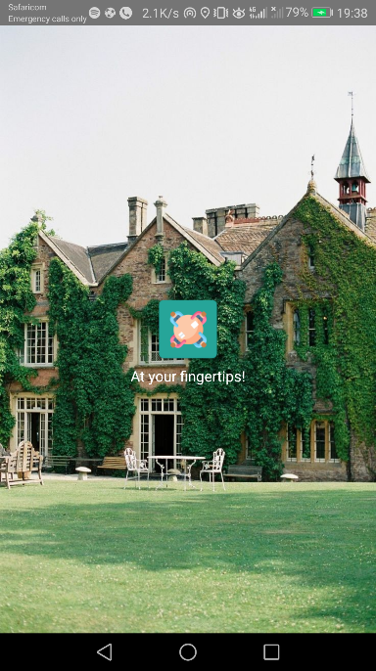

Figure 9: Welcome page with the app’s icon

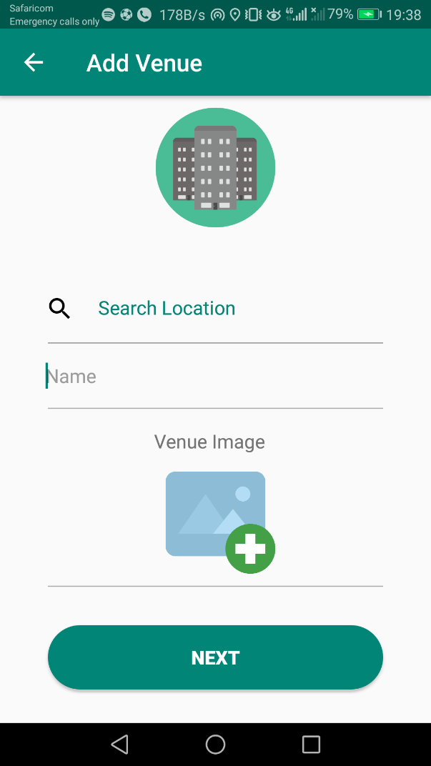

Figure 10: Add Venue Activity where the owner adds his/her venue.

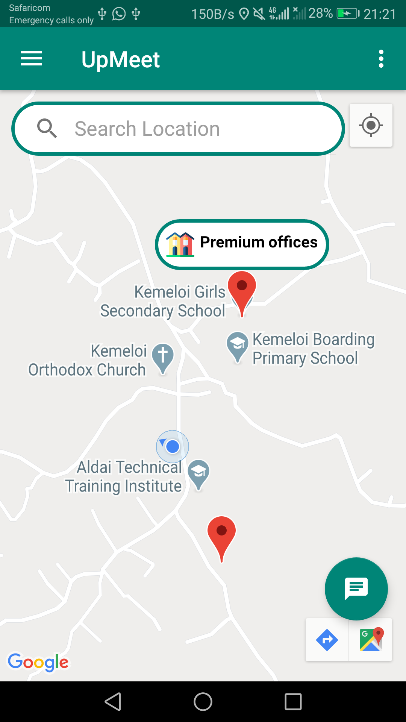

Figure 11: Main page where seekers can view their location and closest venues.

## CHAPTER 4: SYSTEM IMPLEMENTATION

### **4.1: Resources**

The following are hardware and software resources used in the development of UpMeet

* Java for the development of the core software in Android Studio
* Firebase as the project’s database and storage and backend code hosting.
* JavaScript for the development of the server side code in Node.js.
* Visual Studio Code as the code editor for the server side code.
* Huawei P10 for running and testing the application.
* An Intel core i5, 12GB RAM and 256 GB Solid State Drive for both development and project documentation.
* GitHub as the Version Control System

### **4.2: Constraints**

* The app will operate on the Android platform.
* Lengthy process getting the application on Google Play Store

### **4.3: System testing**

The system was tested to ensure that the user objectives are met and that bugs, if any, were fixed.

### **4.4: Unit testing**

The individual components of the system were tested to ensure that they are error and bug free and that error handling mechanisms are working as required and returning the expected results.

#### **4.4.1: Test cases**

These test cases were used to identify the functionality of the system that will be used in the test and that are necessary for successful and acceptable implementation of the system’s requirements.

Table 2: UpMeet test cases

|  |  |  |  |  |  |
| --- | --- | --- | --- | --- | --- |
| **Test Case** | **Module** | **Description** | **Input** | **Expected Results** | **Actual Output** |
| 1. | Login | User Authentication | Enter valid login credentials | Redirected to Home Activity | User is Redirected to Home Activity |
| Enter invalid login credentials | An error message is displayed with the fields with errors highlighted | An error message is displayed with the fields with errors highlighted |
| Enter invalid email address | An error message is displayed with the email address field highlighted | An error message is displayed with the email address field highlighted |
| 2. | Registration | User Registration/ Account Creation | Enter required registration details correctly | Success message and redirect to Home Activity | Success message and redirect to Home Activity |
| Enter invalid registration details | Error message is displayed with the fields with errors highlighted and user is prompted to re-enter details | Error message is displayed with the fields with errors highlighted and user is prompted to re-enter details |
| 3. | Profile | View and edit user profile | Logged in user attempts to view profile | User is able to view the profile | User is able to view the profile |
| User tries to save invalid details | Error message prompting user to fill fields correctly. | Error message prompting user to fill fields correctly. |
| 4. | Add Venue | Add a new venue and populate in the map | Logged in venue owner attempts to add venue | Add Venue activity opens and user is able to add his/her venue. | Add Venue activity opens and user is able to add. |
| User tries to save a blank venue | App does not save the venue but prompts for a valid fields. | App does not save the venue but prompts for a valid fields. |
| 5. | View Venues | Shows the logged in user venues he/she owns. | User with venues tries to view his/her venues | Show venues owned by the user only. | Show venues owned by the user only. |
| User with no venues tries to view their venues | Inform the user that he has not added a venue yet. | Inform the user that he has not added a venue yet. |
| 5. | View Bookings | User views bookings made for facilities. | Logged in user attempts to view bookings | User is able to see facility reservation. | User is able to see facility reservation. |

#### **4.4.2: Sample test logs**

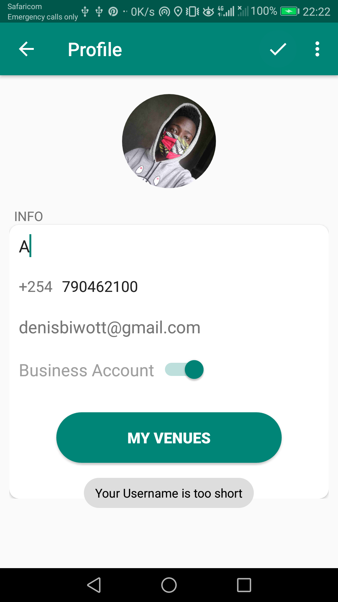

Figure 12: (Profile) Inform user when field is not entered correctly.

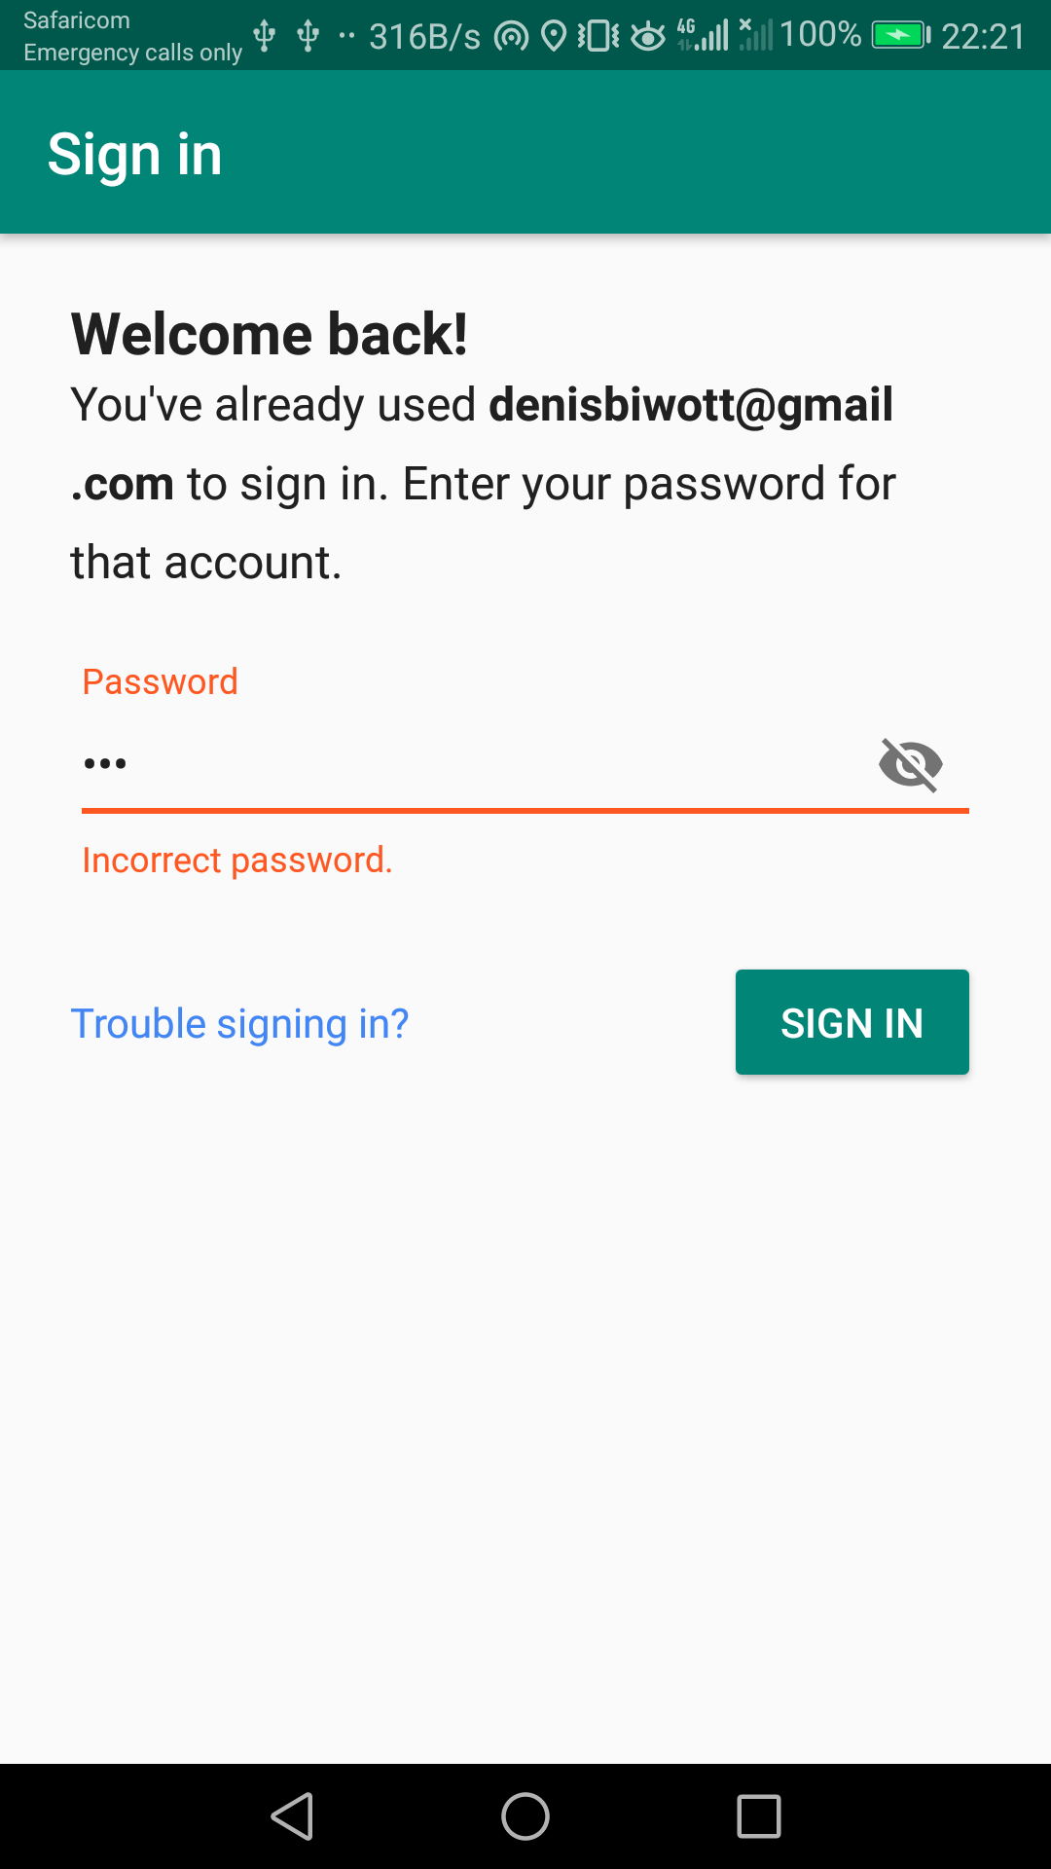

Figure 13: (Sign In) Prompt user when wrong password is entered.

## CHAPTER 5: CONCLUSION AND RECOMMENDATION

### **5.1: Achievements of the system**

The following are the achievements of the developed system:

* Venue owners can sign up and create an account
* Venue seekers can sign up and create an account
* Seekers can look for and find suitable venues
* Seekers can reserve and pay for venues
* Users are able to get notifications and alerts
* Seekers are given directions to the venue
* Venue details are well cataloged complete with prices opening and closing times and images
* Venues are paid for using mobile money
* Users have sufficient guidance and information to navigate the system

Thus:

* Venues get exposure and find new customers
* Seekers easily find suitable venues
* Freelancers, startups and companies save rent costs by reserving a venue only when needed
* Venue seekers make informed decisions when reserving a facility

### **5.3: Challenges and limitations**

The following are the challenges and limitations experienced during the development of the system:

* The app requires internet connectivity.
* Lack of reliable internet connectivity in rural areas.
* The application is android based meaning iOS users will be left out

### **5.4: Further improvements**

Below are improvements that can be made to the system:

1. Make the issue of internet connectivity a non-issue by creating a USSD based app version
2. Develop an iOS version of the app hence ensuring all farmers with different smartphones have access to the app

### **5.5: Conclusion**

Despite the challenges and limitations associated with the app, it is evident that the app requirements are adequately met. In conclusion, the usage of office facilities is evolving and with the changes come advantages. The earlier companies migrate to working remotely and acquiring office facilities only when needed the better.

### **5.6: Appendix**

Diagrams in this paper were drawn using Draw IO - <https://app.diagrams.net/>

The database image is from Firebase Console - <https://console.firebase.google.com/>

Application Icons were sourced from Flat Icon - <https://www.flaticon.com/>

#### **5.6.1: Schedule**

Table 3: Project Schedule

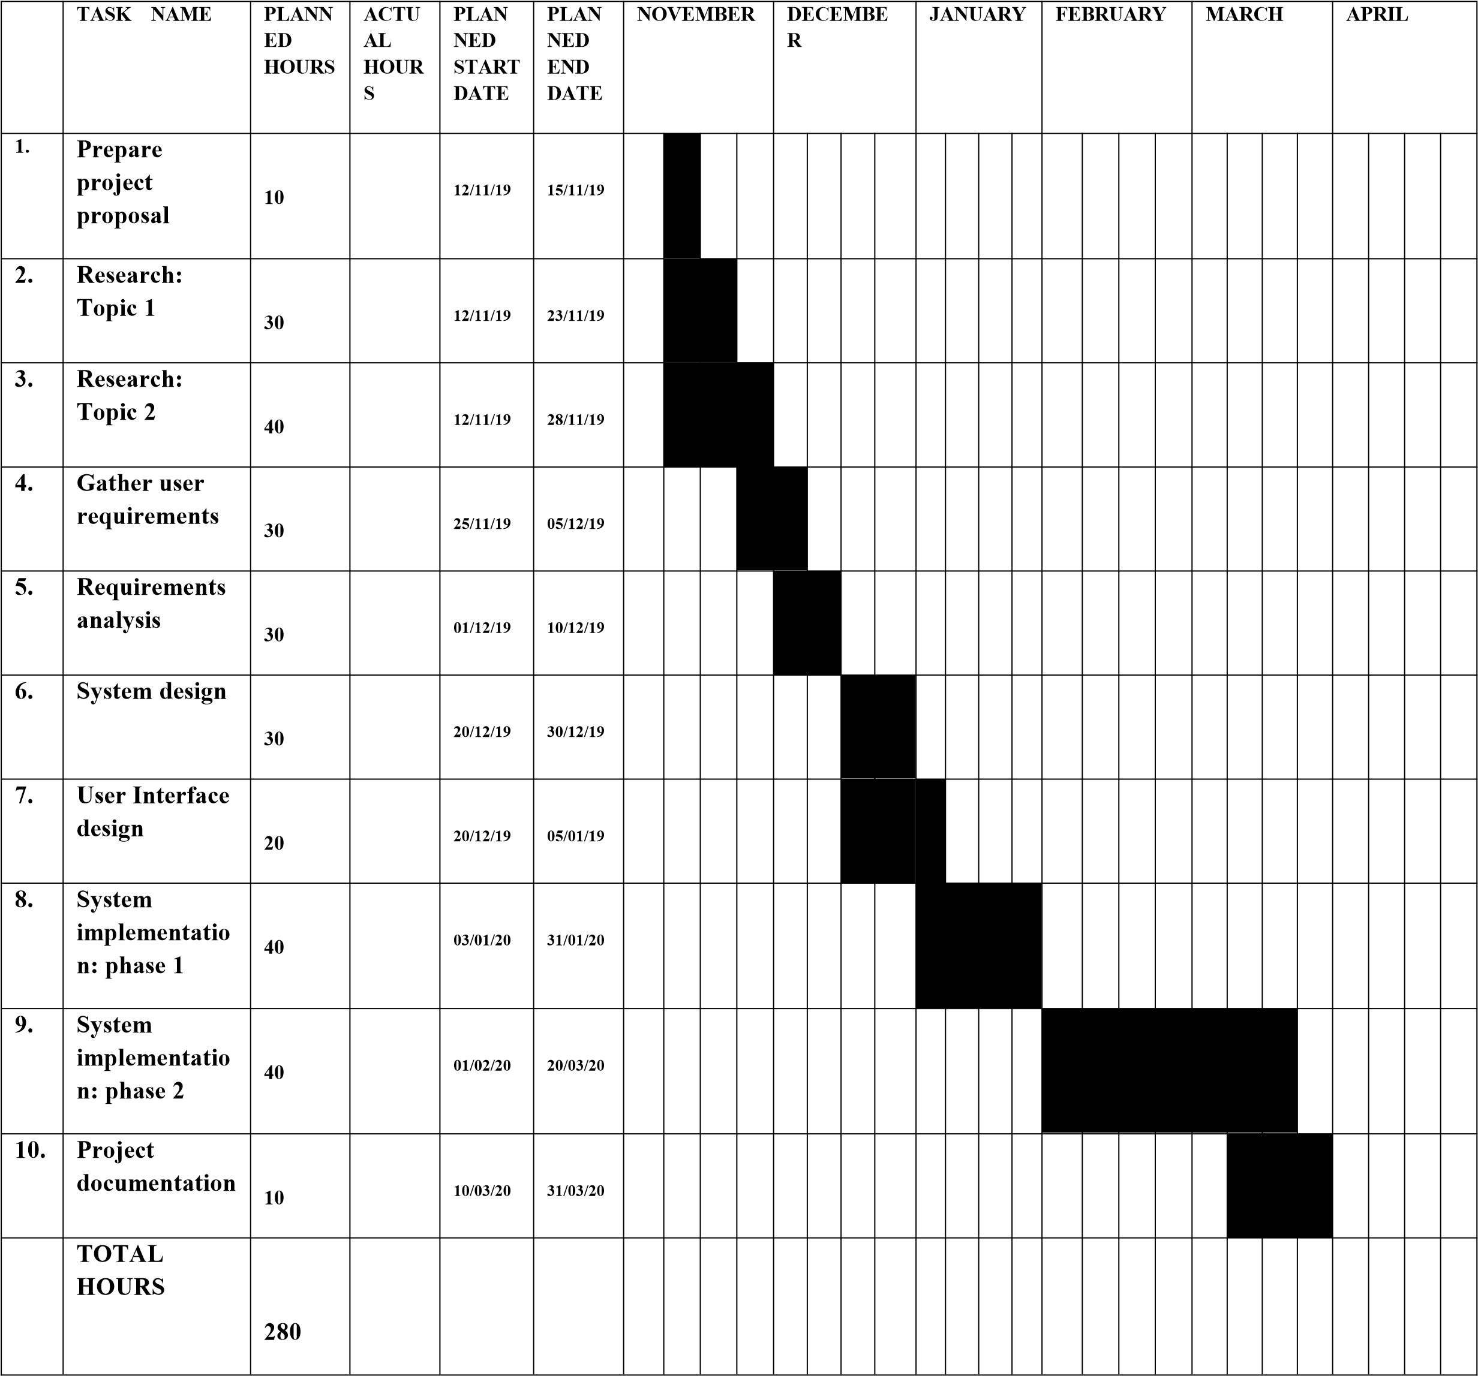

#### **5.6.2: Sample code**

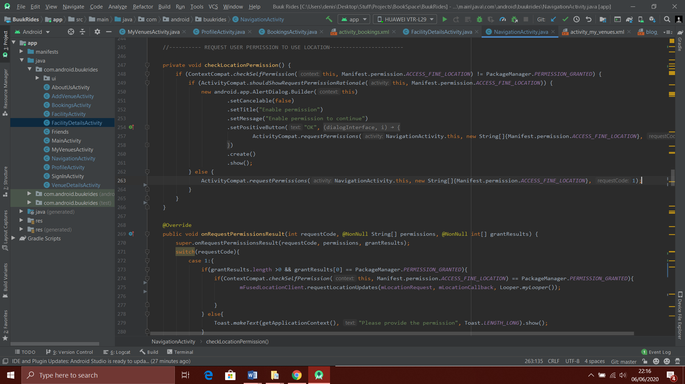

Figure 14: Code in main activity (Navigation Activity) that requests user for location permission

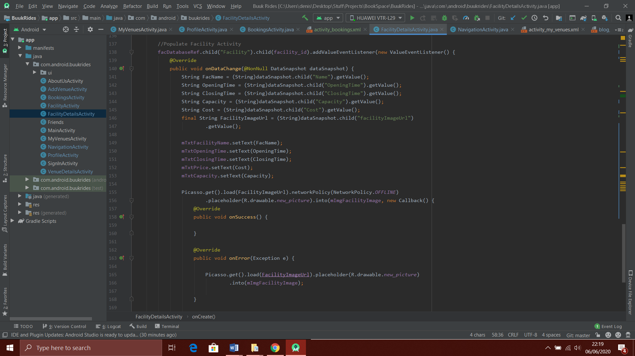

Figure 15: Code in Facility Details activity that retrieves facility data from firebase.

#### **5.6.3: References**

Hannah, F. (2019). The firm with 900 staff and no office. Retrieved June, 6, 2020, from <https://www.bbc.com/news/business-48879976>

Google Learn Digital. Fundamentals of Digital Marketing.(n.d). Retrieved June, 6, 2020, from <https://learndigital.withgoogle.com/digitalskills/course/digitalmarketing>

Khan, U. (n.d). Covid-19 - The long term impacts on the office occupier market. Retrieved June, 6, 2020, from <https://www.lexology.com/library/detail.aspx?g=10b82d20-bf83-4d4a-a6b0-b4cd8c56d358>

Kaya, I. (October, 4, 2019). Is the Future Workplace Officeless? Retrieved June, 6, 2020, from

<https://www.cmswire.com/digital-workplace/is-the-future-workplace-officeless/>

Ofcom (August, 2 2018). A decade of digital dependency. Retrieved June, 6, 2020, from <https://www.ofcom.org.uk/about-ofcom/latest/media/media-releases/2018/decade-of-digital-dependency>

Inc. (n.d). No Office, No Problem: 125 Companies Proving That Virtual Companies Can Thrive. Retrieved June, 6, 2020, from <https://www.inc.com/jessica-stillman/no-office-no-problem-125-companies-proving-that-virtual-companies-can-thrive.html>